Beauty and the Beast – Gary Trousdale & Kirkland Wise, 1991
“Follow Me”
Literacy Focus: Myths, legends, fables, traditional tales

Years 3 – 6 Literacy Plan: Myths, legends, fables, traditional tales
Thinking Film Primary 3 weeks

Clip context
Belle has found her father who went missing after returning from market through the stormy forest at night. He is being kept prisoner in the Beast’s castle. Belle offers to take her father’s place in the Beast’s prison – and despite her father’s protests, the Beast accepts the exchange.

On-going: The Thinking Film Working Wall: We recommend that space is provided for a ‘Thinking Film’ Working Wall / display where children can add words, images and thoughts. This will help visual learners to consolidate the Literacy themes covered in this unit.

Week by week outline
Prior Learning: Identify the elements of a myth, legend, fable or traditional tale.

Week 1: Deconstruct the clip to identify the ‘traditional tale’ elements.

Week 2: Write descriptive paragraphs based on the film clip.

Week 3: Develop own mythical character.

Storyboard own traditional tale

NB: The ‘MUST, SHOULD, COULD’ CATEGORIES REFER TO THE DIFFICULTY OF THE ACTIVITY (e.g. MUST = easy; SHOULD = medium; COULD = hard)

Objectives | Whole class activities | Differentiated independent or group activities | Plenary / focused questions | Success Criteria  Children can:
Week 1  MIND MAP / FILM HIGH FIVE  Focus: Analyse the clip shot by shot. Identify the elements that make it fit the ‘traditional tale’ genre.  Identify the key features and make notes on A2 size paper to create own mind map.  Annotate and add to the mind map after each viewing. Watch the clip in the context of the ‘Film High Five’ (see appendix 3) and in terms of: character; setting and mood. | Watch clip. Ask for initial reactions.  Watch the clip again, this time, introduce the ‘Film High Five’: camera; colour/light; sound/music; editing/pace and mise en scene. Split class into groups: each group has one section to focus on.  Use screen-grabs or pause button to highlight, annotate stills in order to discuss each element of film language.  Later in the week, discuss mood, character development and setting of the clip. | MIND MAPS / FILM HIGH FIVE:  Group 1 (MUST): come up with 3 observations about how camera angle and camera movement is used to help tell the story. Identify at least 3 interesting camera angles.  Group 2: (MUST) identify how music and sound is used to help tell the story on screen.  Group 3: (MUST)  Focus on how colour and light have been used to help tell the story on screen. Choose 3 screen-grabs as examples.  Group 4: (SHOULD) Focus on ‘mise en scene’ – everything that can be seen in the frame. E.g. props, costumes, character positioning and body language. Choose 3 screen grabs as examples.  Group 5: (COULD) Focus on pace / editing. How quickly / slowly are the shots intercut? What effect does this have when watching the clip? How does the pace change? | Discuss the words and images chosen.  Add key ‘Myths / legends mind map’ words and images to the Thinking Film working wall. | Identify and make notes on main points of the text.  Identify features that filmmakers use as storytellers.

Objectives | Whole class activities | Differentiated independent or group activities | Plenary / focused questions | Success Criteria  Children can:
Week 2  FILM HIGH FIVE SENTENCES  Focus: analyse the clip in detail, investigate and write sentences and short descriptive passages through modelled and shared shot-by-shot analysis composition.  Understand in broad terms the key elements of Film Language.  Explore how different texts appeal to audiences by using varied styles, structures and descriptive film language.  Identify features that storytellers use to provoke audience reactions.  Write narrative texts using a range of structures, e.g. descriptions. | Watch and discuss the clip in terms of the FILM HIGH FIVE –  (See appendix 3).  Watch the clip as a class and discuss reactions to it. What is the mood? Genre? Style? Why are we studying it as part of our ‘Myths and Legends’ Unit?  Discuss the idea of camera angles being like adjectives; and music and sound effects being like advervs (adding meaning to the action); and colour and light being like connectives (holding it all together). | Group 1 (MUST): come up with 3 observations about how camera angle and camera movement is used to help tell the story. Decide on suitable adjectives to describe the scene. Identify one key image and write a descriptive sentence about it which includes at least one adjective.  Group 2: (SHOULD) identify how music and sound is used to help tell the story on screen. Describe the clip in a piece of short descriptive writing which includes adjectives and adverbs e.g. Belle flung herself to her knees dejectedly.  Group 3: (COULD)  Focus on how colour and light have been used to help tell the story on screen. Choose 3 screen-grabs as examples. Write a piece of short descriptive writing which includes adjectives, adverbs and connectives. | Each group to feed back / choose the best sentences or piece of descriptive writing to share. | Express their ideas clearly as part of a group discussion  Form ideas about a story and use evidence from the story to explain their reasons  Use the following terms when discussing film:  Frame; colour, light, shadow; movement; sound, music and sequence.  Write sentences about the clip which include (easy) adjectives; adjectives and adverbs (medium) and adjectives, adverbs and connectives (hard).

Objectives | Whole class activities | Differentiated independent or group activities | Plenary / focused questions | Success Criteria  Children can:
Week 3  MY MYTHICAL BEAST  Write descriptive paragraphs.  Select and use descriptive vocab.  Use layout and illustrations.  Signal sequence, place and time in a storyboard  Make decisions about form and purpose.  Use layout, format and graphics. | Watch the clip again – this time focusing on the Beast. Discuss him in terms of appearance; demeanor; voice; actions; physical presence.  Mind map other mythical beasts.  Discuss similarities and differences. | Develop own mythical beast with a backstory (how did it get to where it is now / why does it look the way it does?).  MUST: draw the beast and describe its appearance, voice and actions in 3 sentences.  SHOULD: create a film poster design for the beast with a tag line and a movie title. . Publish own version of  COULD: create a storyboard (see Appendix 4 – storyboard frame) detailing the backstory of the beast and how it came to be. | Describe the mythical beasts and their backstory. | Explain main features of a mythical character type.  Plan own writing with pictures using ideas/features from a particular story type (myth).  Write imaginative descriptions to go with own writing.  Plan a poster, collect images and write draft text.  Use a sensible layout in their writing (sentences with nouns, adjectives, verbs or storyboards with notes and speech).

Appendix 3
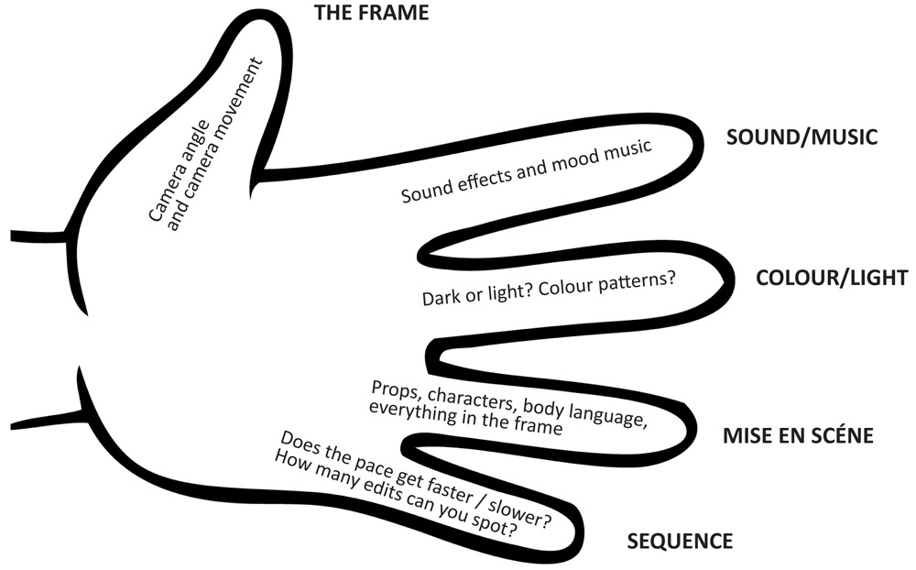
Appendix 4 - Storyboard frame

